Learning Centre page

More than 506 tonnes of waste and 243 tonnes of recycling is disposed of from the North Terrace campus every year. Combined, this weighs as much as **five full-sized blue whales**!

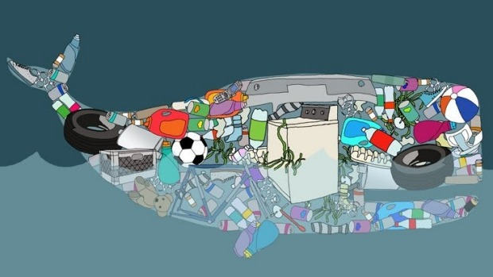

Around 15 tonnes of waste and 12 tonnes of recycling is generated in Hub Central alone, including 73,000 coffee cups and 9 tonnes of food scraps.

Unfortunately, much of this waste and recycling is placed in the wrong bin, which ‘contaminates’ other items in the bin. If recycling or organics bins are contaminated, none of the items in that bin can be recycled and the entire bin will go to landfill – pretty frustrating for the people who are recycling correctly.

This App has been created to help teach correct recycling practices in order to increase recycling rates and decrease volumes of waste to landfill.

**What Goes Where?**

If it once lived, it can go in the **green food scraps bin**.

* Food and liquids: including banana peels, apple cores, left-over salads and sandwiches, sauces and egg shells
* Coffee grinds and tea bags
* Paper towel and tissues

If it can be turned into something useful, it can go in the **yellow recycling bin.** Just make sure you tip out all liquid and food scraps first.

* Takeaway coffee cups
* Hard plastic containers
* Glass and plastic bottles
* Tin cans
* Milk and juice cartons
* Paper and cardboard (if there is no blue paper bin available)

Everything else, goes in the **red general waste bin**.

* Plastic wrap and shopping bags
* Chip packets and foil wrapping
* Dirty food containers
* Polystyrene cups and trays

If you are unsure about what goes where, put your item in the general waste bin.

CCO2 page

*Please add this text to the top of the page*

In Australia, more than 8 million tonnes of food waste is generated each year, most of which ends up in landfill. Once in the ground (unless regularly turned over), food waste breaks down slowly due to a lack of oxygen and emits potent greenhouse gas emissions including C02 and methane.

**How does this compare to the emissions produced through electricity use?**

The average Australian household produces 12kg of CO2-e per day. Emissions produced from 8 million tonnes of food waste could power more than **3.6 million houses**.

Use this calculator to get a picture of how the greenhouse gas emissions from different sorts of waste compare to that of electricity.

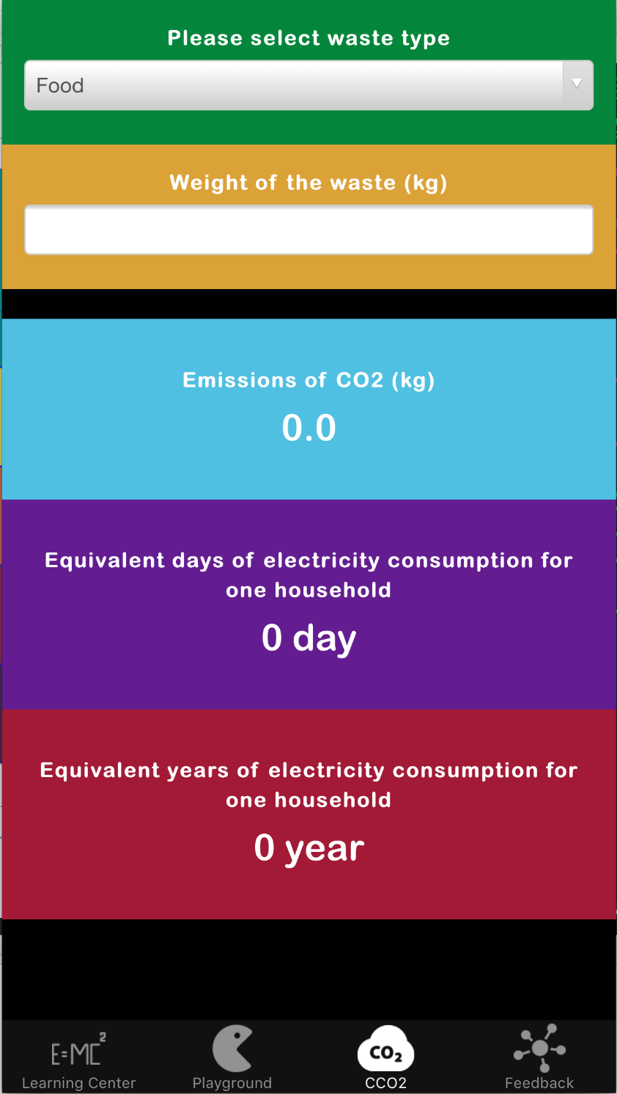**NEW TEXT**

|  |
| --- |
| Select waste type |
| Weight of the waste (kg) |
| Emissions of CO2-e (kg) produced in landfill |
| Equivalent days of electricity consumption for one household. |
| Delete the yearly equivalent. |

Should this be CO2 rather than CCO2?